**UML DIAGRAMS FOR RTSA**

* Use case Diagram:

**+-------------------------------------------+**

**| User |**

**+-------------------------------------------+**

**|**

**| Performs Sentiment Analysis**

**|**

**+---------------------------------------------+**

**| Sentiment Analysis System |**

**+---------------------------------------------+**

**| |**

**+----------------------------+ +---------------------------------+**

**| Perform Analysis | | Gather Feedback |**

**+----------------------------+ +---------------------------------+**

* Class Diagram:

**+----------------------------------------------+**

**| Sentiment Analysis System |**

**+----------------------------------------------+**

**| |**

**| |**

**+-------------------+ +----------------------+**

**| Preprocessor | | Analyzer |**

**+-------------------+ +----------------------+**

**| |**

**| |**

**+------------------+ +-------------------------------------------+**

**| Vectorizer | | Machine Learning Algorithms |**

**+------------------+ +-------------------------------------------+**

**| |**

**| |**

**+-------------------+ +-----------------------------+**

**| Data Loader | | Result Presentation |**

**+-------------------+ +-----------------------------+**

* Activity Diagram:

**+-------------------------------------------------------+**

**| Sentiment Analysis System |**

**+-------------------------------------------------------+**

**| |**

**| |**

**| +------------------------+ |**

**| | User Interaction | |**

**| +------------------------+ |**

**| | |**

**| | |**

**| +-----------------------+ |**

**| | Input Processing | |**

**| +-----------------------+ |**

**| | |**

**| | |**

**| +----------------------------+ |**

**| | Sentiment Analysis | |**

**| +----------------------------+ |**

**| | |**

**| | |**

**| +---------------------------+ |**

**| | Result Presentation | |**

**| +---------------------------+ |**

**| |**

**+-------------------------------------------------------+**

* Sequence Diagrams:

**+--------------------------+ +----------------------------+**

**| User | | Sentiment Analysis |**

**+--------------------------+ +----------------------------+**

**| |**

**| Submit Text |**

**|-----------------------------> |**

**| |**

**+---------------------------+ +------------------------+**

**| Sentiment Analysis| | Preprocessor |**

**+---------------------------+ +------------------------+**

**| |**

**| Preprocess Text |**

**|-----------------------------> |**

**| |**

**+---------------------------+ +----------------------+**

**| Sentiment Analysis| | Analyzer |**

**+---------------------------+ +----------------------+**

**| |**

**| Analyze Sentiment |**

**|-----------------------------> |**

**| |**

**+---------------------------+ +----------------------------+**

**| Sentiment Analysis| | Result Presentation |**

**+---------------------------+ +----------------------------+**

**| |**

**| Present Results |**

**|-----------------------------> |**

**| |**

**System Design**

* **Use-Case Diagram**

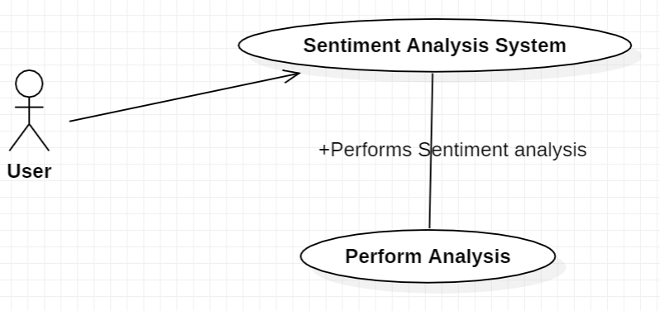

* **Class Diagram**

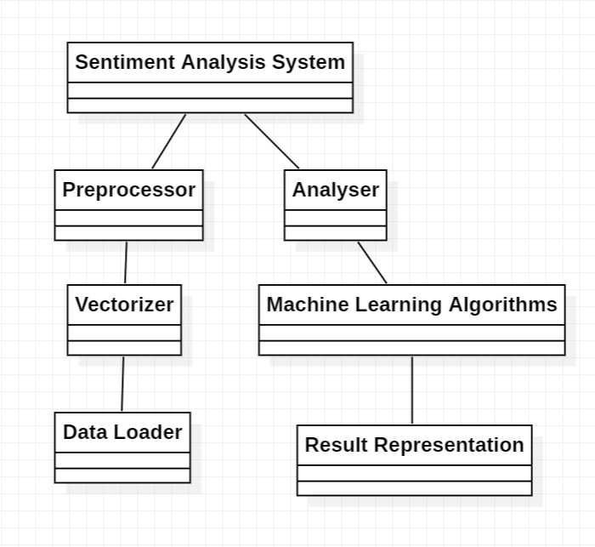

* **Sequence Diagram**

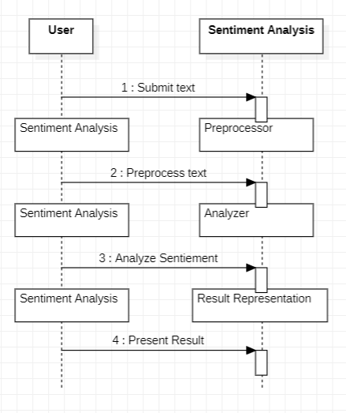

* **Activity Diagram**

